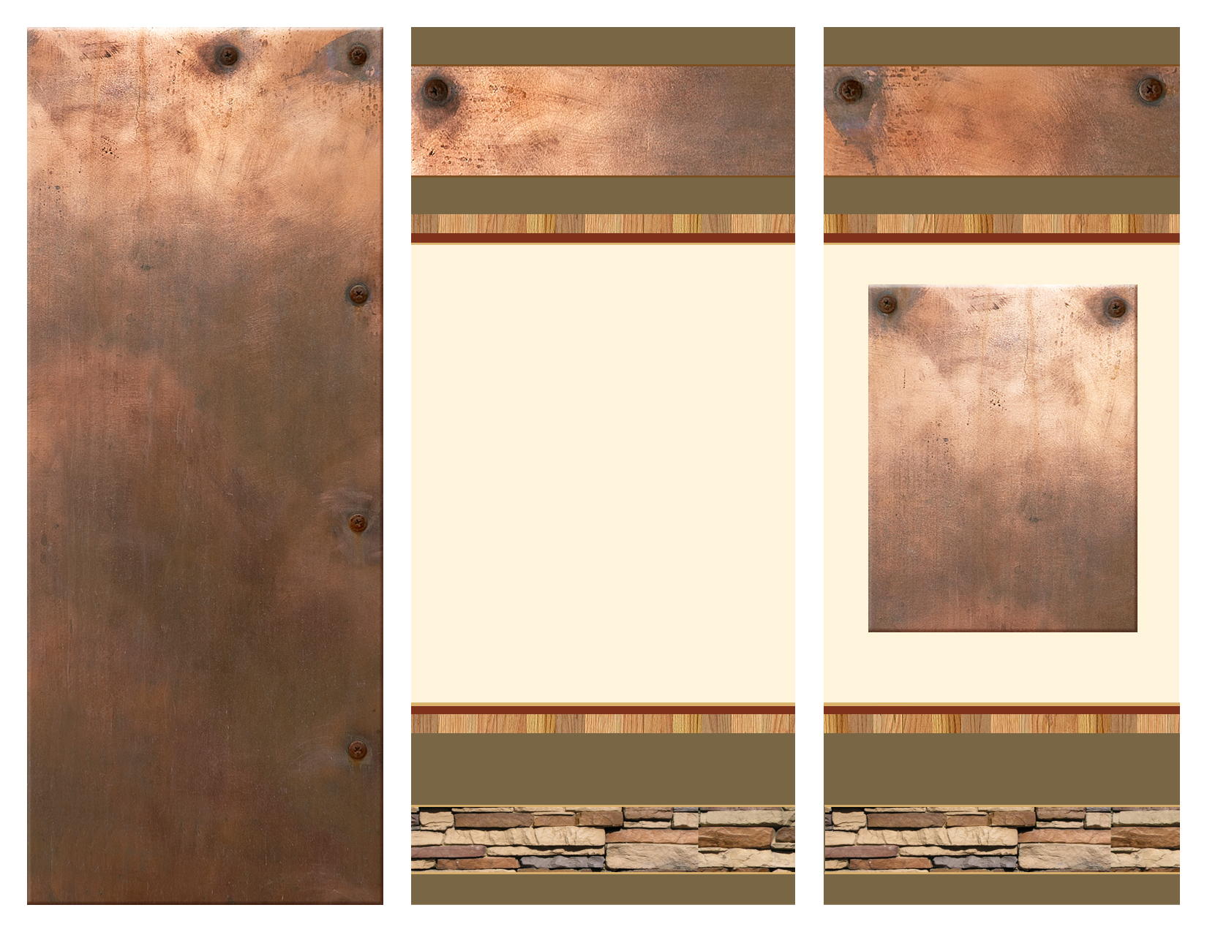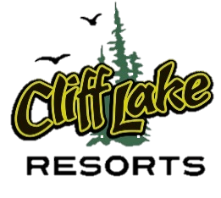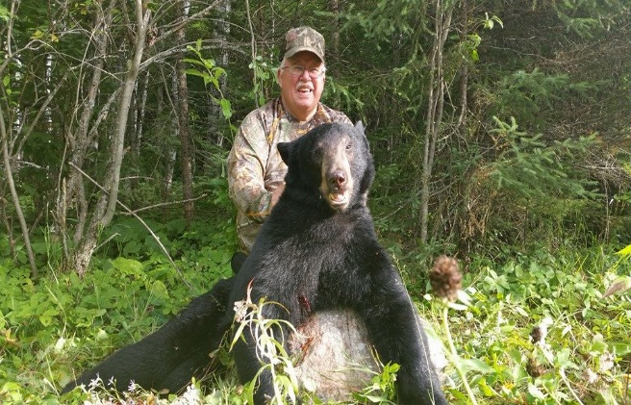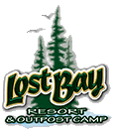

**\*\*Bear Hunters Special\*\***

**\*\*ONLY $990\*\***

**as low as**

[your-url-goes-right-here.com](http://www.your-url-goes-here.com)

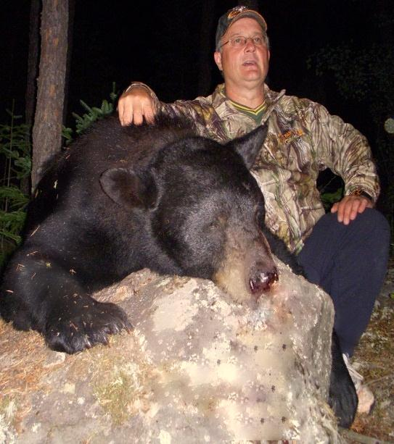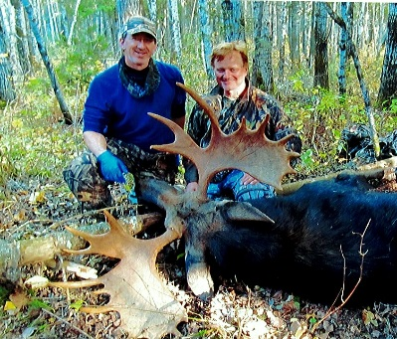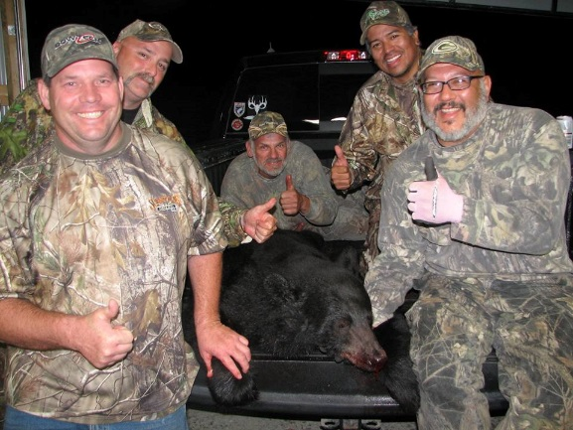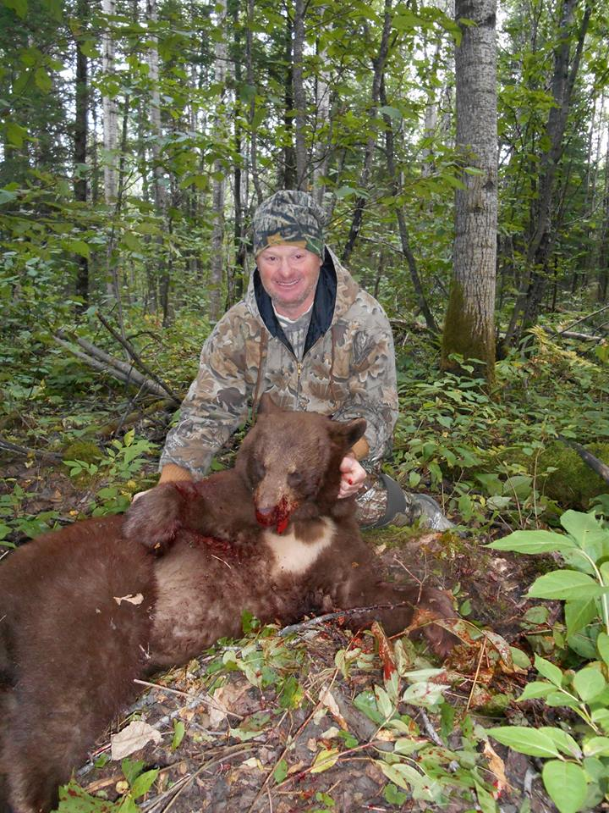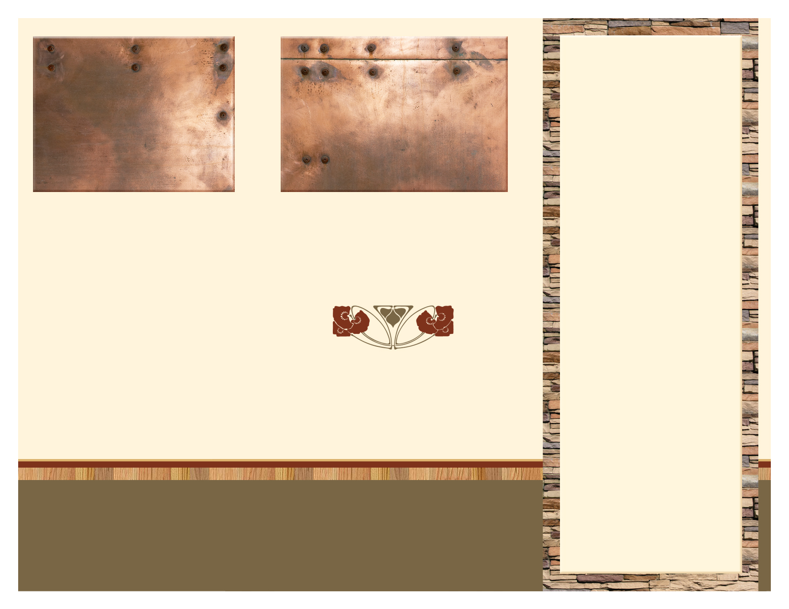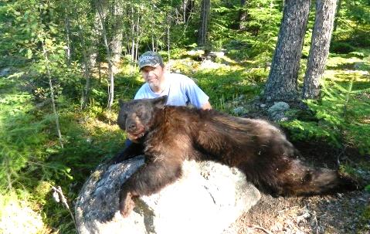

**Cabin Information**

At Lost Bay Resort: All cabins and homes are equipped with indoor bathroom with shower, bed linens, stove, microwave, refrigerator, dishes, cooking utensils and BBQ grill.

Luxury Package: Executive Timber Frame lodging provides all of the above plus two full bathrooms, five queen beds and one twin, dishwasher, flat screen TV with DVD player, unsurpassed views on a wrap-around deck and a private dock.

At the Outpost: All cabins are equipped with stove, refrigerator, dishes, cooking utensils and BBQ grill. Shower and toilet are located in a central, modern bathhouse. At the Outpost we ask you to bring your own pillows, sleeping bags or other bedding.

**Hunting/Fishing Packages:**

Additional **$300** - Includes: boat, motor and first tank of gas per week – 3 person per boat

Fishing included in “Luxury Package”

**Services provided at Lost Bay Headquarters** Freezer service, fuel, minnows and other bait sales, light tackle, and ice.

2016 Pricing List

**Pricing: Semi Guided, housekeeping, 7- day fall Bear hunts:**

**$990**; plus tax - per bear hunter

**Luxury Hunting Package**

**$1,500** per hunter - Minimum 4 hunters

Only hunting group in camp

Tax Included

Fishing package includes: boat, live bait, fuel

Luxury accommodations

Staff does all baiting

**Pricing: Non Resident, Housekeeping, 7- day moose hunt.**

**Price for 2-person hunt:**

* Rifle Hunt - $4,995: 2 hunters 1 Bull Tag, One Calf Tag. Every additional Hunter in party carries a calf tag: $500 each additional
* Archery Hunt - $2,750: 2 hunters 1 Bull Tag, One Calf Tag. Every additional Hunter in party carries a calf tag: $500 each additional

**Licenses, permits and taxes not included**

A $350.00 US non-refundable deposit by cashier's check, personal check made out to Cliff Lake Resorts or Visa, MasterCard, American Express, Discover payment is required per hunter when booking. All bookings and deposits must be received by May 15th or the time slot will be sold to another party. The balance due for the hunt is paid upon checking in. This assures you, as well as us, of your booking. If there is a cancellation, your deposit will be applied to the following year's hunt, provided we can fill your party’s spot. If we cannot find other hunters, your deposit will be forfeited.

2016

Bear & Moose Hunts

Cliff Lake Resorts

W194 N11551 McCormick Dr.

Germantown, WI 53022

L-1502

Ph. 888-884-8870 | 262-509-3010 |Lostbayresort.com

See details on 2016 Pricing List

**Introducing our Luxury Hunting Package**

**$1,500**

Minimum 4 hunters – All inclusive housekeeping package

Cliff Lake Resorts offers semi-guided, baited bear hunts. Stands are baited within our official Bear Management Area. Starting weeks prior to the arrival of the first hunting party – dependent on weather and natural feeding conditions. The majority of our BMA is located where access is via vehicle or by water. **Hunters are responsible for their own skinning and processing**; a new indoor cleaning facility has been built at Lost Bay for our hunter’s convenience, with large freezer space. The packaged bear hunts include a housekeeping cabin, private bathrooms and help, if needed, in retrieval of your animal. The bait for the six-day bear hunt will be provided, along with an orientation of the BMA upon arrival. Bringing an ATV or 4WD vehicle is recommended.

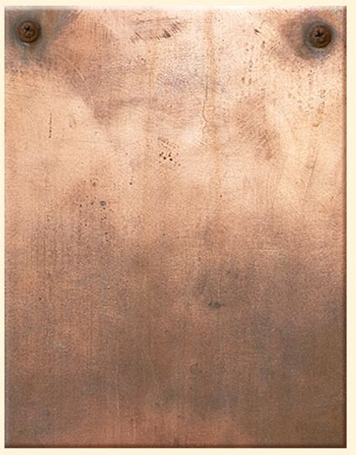

**Lost Bay & Outpost Camp Non- Resident Moose Hunt**

This six day moose hunt will appeal to the seasoned hunter that has done the calling, tracking, field dressing, and processing of their animal - Individuals will be responsible for skinning and cutting of the animal; a large freezer is available for the meat and hide. Staff is available for assistance in moving and hanging upon request.

Lost Bay Resort moose hunts include housekeeping cabin(s). If requested, a boat and motor will be provided – first tank of gas is free. An ATV or 4WD vehicle is recommended if you wish to access areas not adjacent to the lake. Ontario law requires registration and insurance from your home state, along with a helmet.

Lost Bay Resort and Outpost each are equipped with 1 rifle or 2 Archery Bull Moose tags and unlimited Calf tags.

A Gun hunting license from your home state is required to get a moose license in Ontario. Hunter orange clothing is also required – **camouflage orange is not acceptable in Ontario.**